**ASSIGNMENT – 2**

**TEMPERTURE AND HUMIDITY**

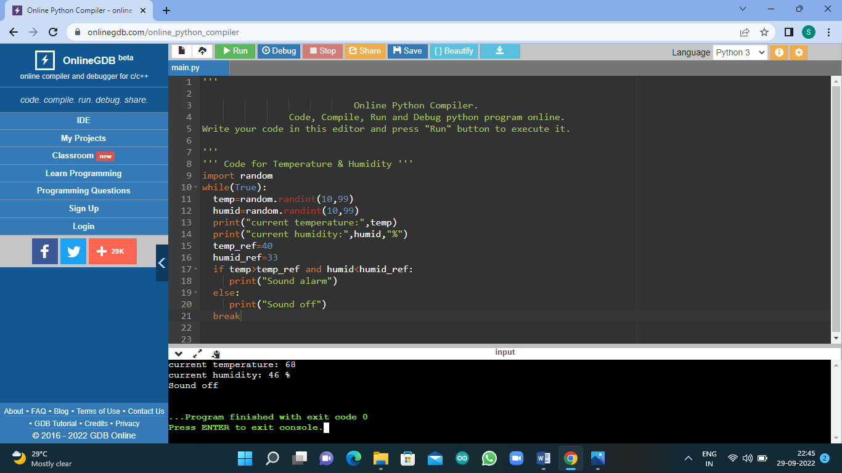

**Python Code for Temperature & Humidity :**

import random

while(True):

temp=random.randint(10,99)

humid=random.randint(10,99)

print("current temperature:",temp)

print("current humidity:",humid,"%")

temp_ref=40

humid_ref=33

if temp>temp_ref and humid<humid_ref:

print("Sound alarm")

else:

print("Sound off")

break